THIS PAGE IS STILL UNDER CONSTRUCTION!
Feel free to poke around, but do not start the lab as things might change!
Lab 9: fMRI Part 3: Group Analysis with FSL

Information, Preparation, Resources, Etc.

Assigned Readings / Videos:
- tbd

Goals for this lab:
This lab will continue the analysis that you started in in the previous lab. Last time, you used FSL to analyze two (for the Motor task) or three (for the Face task) runs of data from a single subject. Tonight you will conduct Second Level Analysis that will combine the results across those runs. You will then perform a Third Level analysis (aka 'Group'), which will combine the data across several subjects.

Software introduced in this lab
- n/a

Laboratory Report
Lab Report #9 is due on Apr xxth @ 1:10 pm.
- Throughout this (and all) lab exercise pages you will find instructions for your lab reports within these boxes.

Housekeeping
Some of the images used in tonight's lab are from earlier versions of FSL (and/or from FSL running on a Linux machine), so they might not always look identical to what you see when running the program. However, the display should be very similar. I have updated the images in all cases in which the display looks substantially different.

Data used in this lab
- You will continue working on the data you were previously assigned for labs 7 and 8.
  - Therefore, all of your output from tonight's lab should continue to go into ~/Desktop/output/lab08

Part 1: Second level analysis
As mentioned in the last lab, a second level analysis combines the results of two or more first level analyses, and thus provides summary statistics across the runs for an individual subject.
Remember, a run refers to a single continuous data acquisition period. There are several reasons you would divide your study up into separate runs. One such reason is to give your subjects intermittent rest periods. If you have an experiment that requires 40 minutes to complete, you might break that up into eight 5-minute runs.
The inputs to a second level analysis are not raw image volumes, but rather consist of the first level statistics and variances. In other words, each voxel does not contain a time-series of datapoints, but rather the statistics that were calculated at the first level. For that reason, second level analyses run much faster than first level analyses.
FSL uses a sophisticated approach to combining First Level Analyses into a Higher Order Analysis that is discussed here.
To save yourself a lot of traversing through file manager boxes to find the relevant files, launch fsl from a terminal in which you first change your current directory to a helpful place. For example, you might first cd /Users/hnl/Desktop/output/lab08 and then start fsl fsl &.

Data Tab
1. Initiate a second-level analysis in FEAT
- Choose the Higher Level Analysis drop down button at the top of the FEAT GUI
  - note, by default, this button is set to First Level Analysis, so you have to click on it to choose Higher Level Analysis.
When you choose Higher Level Analysis, the GUI box changes to a more simplified set of options than are available for First Level Analysis. This is because the pre-processing steps that are carried out on the data in First Level Analysis are not needed for Higher Level Analyses. Here is the GUI that you should see.
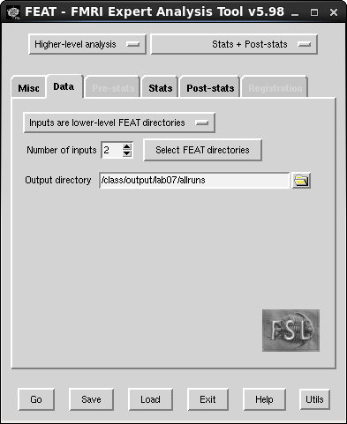

Stats Tab
The stats tab is used to specify your statistical model.
- Choose a Fixed Effects model (see box below).
Fixed-Effects vs Mixed-Effects
A fixed-effects analysis allows us to make inferences about our sample, whereas a mixed-effects analysis allows us to make inferences about the population (to learn a bit more about this you can see here).
A fixed-effects model is appropriate when “averaging” across runs because we are not trying to generalize the results beyond our sample. The across-runs results *is* the effect for our participant.
However, this would not be appropriate when “averaging” across participants, because we will be using those results to generalize beyond our sample. So in that case we would use a mixed-effects model.
Return to the Data tab.

Data Tab
You will be providing as your input to the second level analysis, the output directories created in your first level analyses.
- Thus, choose Inputs are lower-level FEAT directories as your input source.
- Set Number of inputs to however many first level analyses your ran (3 for faces, 2 for motor)
- Select Select FEAT directories
  - Specify the output .feat directory from each run of the first level analysis
    - e.g., ~/Desktop/output/lab08/run01.feat
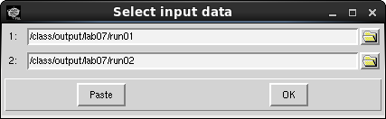
3. Specify output
- Enter /Users/hnl/Desktop/output/lab08/allruns in the Output Directory box.

Stats Tab
Return to the Stats tab.
4. There are two options for specifying your model. Because we have such a simple model, we can use the Model setup wizard and choose the default. Press Process when you are finished.
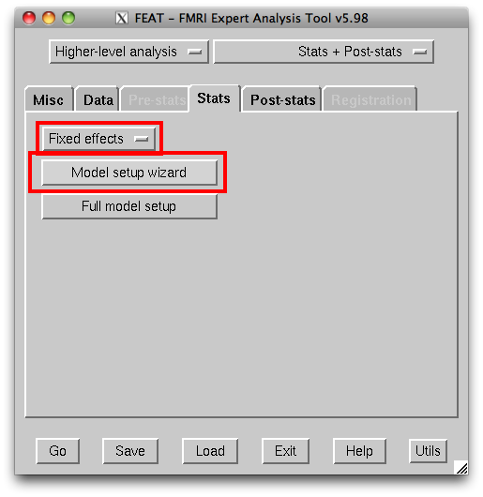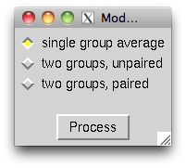

Post-stats Tab
The Post-stats tab will look the same as for the first level analysis. You must choose a method for correcting for multiple comparisons. The default is to use a cluster correction with a a single voxel considered significant with a Z threshold of 3.1 (equal to p < .001). The cluster correction will then further restrict significant voxels to only those in clusters with a Cluster correction threshold of p < .05.
For your lab, I want you to compare two different methods for correcting for multiple comparisons. We will compare the results of analyzing the data uncorrected with the results when we use cluster correction.
When FEAT runs additional analyses with the same output folder specified, it appends a + to the output folder name. This is convenient, in that you don't overwrite your prior output. So, be sure to pay attention to what output folder you are examining.
1. Run the Uncorrected second-level analysis
- Set Thresholding to Uncorrected
- Set the Uncorrected voxel p threshold to .01.
- Press Go
2. When the Uncorrected analysis is finished (the HTML file will no longer read Still Running), re-run the second-level analysis using a cluster correction.
- Set Thresholding to Cluster
- Set the Z threshold to 2.3 (this is equivalent to the p < .01 voxel threshold we used above)
- Set the Cluster P threshold to .001
- Press Go
You will compare the output of these two analyses as part of the next section.

Exploring your Second Level Analysis
To get a quick overview of your results you can explore the HTML output file. If you click on Results you will see a list of the four contrasts you specified in the first level analysis:
- task A vs baseline
- task B vs. baseline
- task A > task B
- task B > task A
You can click on any of these to see the results overlaid on a series of 2D “slices.”
This is a convenient way to get a quick look, but that format is too rigid to fully explore your results given that the HTML output is not interactive. So in this section we will use FSLeyes to drill down into your data.
When FSL combines data from different sources (e.g., run01 and run02), it does not assume that the data were originally located in the same 'brain space' (even though, in this case, they were). It thus combines the data into a common space. In your second level analysis, the statistical overlays are (by default) in MNI152_2mm space. Thus, we will overlay your statistics on the MNI152_T1_2mm_brain.
1. Load the MNI152_T1_2mm_brain in FSLeyes
You can now overlay one or more statistical results.
FEAT creates lots of output files. I've highlighted some critical directories and files below. A full list and description of these files can be found here.
The statistical overlays are located in the output folder that you specified for you second level analysis (e.g., allruns.gfeat). This folder will contain several sub-folders - for example, cope1.feat, cope2.feat, cope3.feat, and cope4.feat.
COPE stands for contrasts of parameter estimates.
= our observed signal
= our predicted signal
= parameter estimate (how much our predicted signal accounts for our observed signal)
= residuals (the variance we cannot explain)
The parameter estimates (aka beta values) are the estimated values that represent how much of a particular expected activation template (aka explanatory variable, aka regressor, aka predictor) exists in each voxel of the brain. That is, how much of the variance can be explained by our model.
We contrast differences in how much variance is explained by different experimental conditions. So, a COPE might tell us whether the how much of the estimated face activation template exists in a particular voxel statistically differs from the how much of the estimated scene activation template for that same voxel.
In our analysis of the face task:
- COPE1 is the face main effect (or right hand) showing all voxels where the face regressor was significantly fit by the data
- COPE2 is the scene main effect (or left hand) showing all voxels where the scene regressor was significantly fit by the data
- COPE3 is the faces vs. scenes contrast and will only show voxels where faces activated the voxel significantly more than scenes
- COPE4 is the scenes vs. faces contrast and will only show voxels where scenes activated the voxel significantly more than faces.
The file names within each of these COPE folders are identical, so it is essential that you take your time and be absolutely sure that you are always in the directory you want to be in / think you're in.
At the top level of the folder is a file named thresh_zstat1.nii.gz. This is the z statistic map for the specified contrast that has been corrected for multiple comparisons by whichever method you selected. It is a 3D volume, as the z statistic was calculated at all voxels. However, z scores that were above your threshold for significance (i.e., p > .05) have been eliminated. Thus, when you overlay this image on your background brain, you will only see color where the differences met your significance criterion.

Effects of Cluster Correction
Let's explore the effect of cluster correction by looking at the results from cope3 (face > scene or right hand > left hand)
2. Load uncorrected second-level analysis
- File ⇒ Add overlay from file ⇒ the thresh_zstat1.nii.gz from the cope3 directory of your uncorrected second-level analysis
  - If you followed the instructions above, this will be the allruns.gfeat directory
- Change the voxel colors from Greyscale to Blue-Lightblue
3. Load cluster corrected second-level analysis
- File ⇒ Add overlay from file ⇒ the thresh_zstat1.nii.gz from the cope3 directory of your corrected second-level analysis
  - If you followed the instructions above, this will be the allruns+.gfeat directory
- Change the voxel colors from Greyscale to Red-Yellow
You can now compare the effect of multiple comparisons correction. The red voxels (corrected) are on top of the blue voxels (uncorrected). So anyplace you see a blue voxel is a location that is being reported as significant in the uncorrected analysis but not significant in the cluster corrected analysis.

LAB REPORT Part 1A
LAB REPORT Part 1A
- We know that there are false positives (Type I error) in the uncorrected results. Include a figure that compares the uncorrected and corrected results showing an area that you believe to be a false positive in the former, that was cleaned up by the latter.
- Correcting for multiple comparisons can sometimes lead to voxels that are truly active being disregarded (“false negative”, aka Type II error). Include a figure that compares the uncorrected and corrected results showing an area that you believe to be a “true” activation in the former, that was erroneously removed in the latter.
Before proceeding, remove the uncorrected results from your Overlay list by highlighting the file and clicking the - button. If done correctly, all of the blue voxels will disappear.
4. Click around in the brain and see if you can identify areas of particularly “strong” activation. If you have a very active participant, it might help to raise the Min value to something higher than 0. This number is the minimum z-score that a voxel must have in order to be shown. So the higher you make it, the fewer voxels you'll see. But those voxels that remain will be the most active (the highest z-scores).
Try changing the Min value from 0 to 2. You'll notice that the colors change a little because the color-bar has been rescaled to have 2 as the minimum. But importantly, you won't see any voxels disappear. Huh? I thought raising the minimum would get rid of voxels with z < 2. So why don't we observe a change.
Let me know if you figure it out.
Where am I? To identify where in the brain a particular voxel is located, you can use the FSLeyes atlas tools. Press option + command + 6 to add the atlas pane to the bottom of the FSLeyes window (It might take the atlas a few seconds to load). Now, as you click around in the brain, FSLeyes will report where you are in the brain according the the Harvard-Oxford Atlas.

LAB REPORT Part 1B
LAB REPORT Part 1B
- Find a cluster of activation on the right fusiform gyrus (for the face task) or the right motor cortex (for the motor task) and include this figure in your report.
Tip: If you have a very active participant with big clusters, you'll want to raise the Min value until the clusters are small enough for you to localize them on the anatomy.
5. Load results of your scene > face (or left hand > right hand) contrast.
- File ⇒ Add overlay from file ⇒ the thresh_zstat1.nii.gz from the cope4 directory of your cluster corrected second-level analysis
- Change the overlay color to “Blue-Lightblue”.
Explore the results the same way you did in the last part (it might be helpful to hide those results).

LAB REPORT Part 1C
LAB REPORT Part 1C
- Find a cluster of activation on the right parahippocampal gyrus (for the face task) or the left motor cortex (for the motor task) and include this figure in your report.
Tip: If you have a very active participant with big clusters, you'll want to raise the Min value until the clusters are small enough for you to localize them on the anatomy.

Part 2: Third Level Analysis
You should now have completed and explored a second level analysis of your subject's data. The next step is a third level analysis in which you combine the second level analyses from two or more subjects. We have fifteen subjects in each of our two tasks: face and motor. Your third level analysis will combine the data from all of them.
Normally, you would first have to conduct first and second level analyses for each of these subjects before proceeding to the third level step. However, because you now have done this for one subject, there is nothing more to learn by running the additional subjects needed for your third level analysis except patience (and the value of scripting!). Therefore, these analyses have already been done for you and you can proceed directly to the third level analysis.

Data for third level analysis
The following fifteen participated in the Motor and Face tasks:
2545 2552 2553 2554 2585 2731 2766 2767 2814 3850 3855 5743 5744 5769 5770
Note: averaging our results across 16 subjects would improve our SNR by 4 times (square root of 16).
The second level analysis results for the face study are located in the following location for each participant:
~/Desktop/input/fmri/loc/analysis/fsl/SUBJ/face_allruns.gfeat
The second level analysis results for the motor study are located in the following location for each participant:
~/Desktop/input/fmri/loc/analysis/fsl/SUBJ/motor_allruns.gfeat
Within the TASK_allruns.gfeat directory there is
The input to third level analysis will be the relevant cope file, cope1.feat within the second level allruns.gfeat directory the results for each cope are in their own subdirectories:
- cope1.feat (Task B)
- cope2.feat (Task A)
- cope3.feat (Task B > Task A)
- cope4.feat (Task A > Task B)
The third level analysis combines the data for each cope across all subjects. So each time you run a third level analysis, you are focusing solely on just one of your first/second level contrasts. This means that you need to run four separate third level analyses for your experiment, one for each COPE.

Data Tab
1. Open FEAT if it is not open already and select Higher-level analysis (instead of First-level analysis)
2. Set Number of inputs to 15 inputs (one per each of subjects who were run in your task of interest).
3. Click on Select FEAT directories. This will open a window in which you need to specify the names of your COPE directories - one per subject.
Typing out the long path to each cope.feat directory would be laborious and error prone. Instead, I recommend you use the folder icon to manually select the first directory and then copy and paste that to the remaining 14 fields (see yellow tip box below for cut and paste instructions on this system). Of course, you'll then need to go in and change the subject number on each line, but this is still much easier than the alternative.
After you select the first file, and before you copy it to the other 14 fields, I recommend that you replace /Users/hnl with ~. This makes the path short enough that you can see the cope number. This will make your life easier because you'll need to change that number on each line each time you run third level analysis on a different cope.
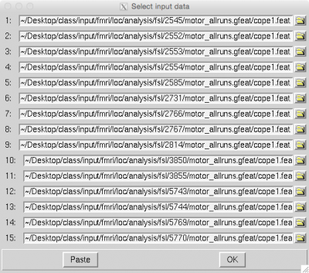
How to Cut and Paste
X11 (aka XQuartz) is a window system that allows us to use the graphical user interface of Unix-based programs like FSL. Unfortunately, the cut and paste function in X11 does not work exactly as you might expect.
To copy text: You can copy text just as you would elsewhere in the operating system.
- Click on the X11 icon in your dock (the black X in an orange circle)
- From the file menu select Edit ⇒ Copy
- Alternatively, you can sue the keyboard shortcut Command+C
To paste text: Pasting is where things get weird (relative to what you're used to).
- If you are using a three-button mouse, you can place the cursor where you want to paste the text and simply click the third button (often this is the scroll-wheel button).
- If you are using a two-button mouse or a trackpad you need to first change a setting in the preferences (you'll only need to do this one time).
  - In the Mac menu bar select X11 ⇒ Preferences and then on the Emulate 3 button mouse
  - Now you should be able to paste text simply by holding down the option key and clicking where you want the text inserted.
4. Specify your Output directory for the COPE you are analyzing. For instance, /Users/hnl/Desktop/output/lab07/allsubs_cope1
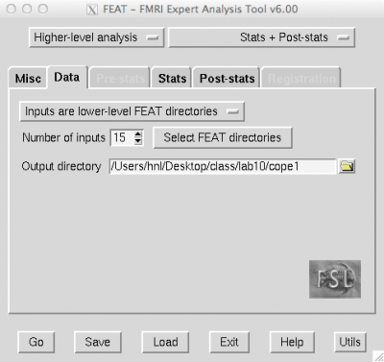

Stats Tab
Go to the Stats tab and set up your third level model. Our model is simple, and so we can click on the Model setup wizard and choose single group average. Note, when we ran our second level analysis we used a Fixed effects model. Here we are averaging across different participants, so we will use the default Mixed effects: FLAME 1 model. We're using Mixed effects because our run level information is fixed effects, but our participant level information is random effects
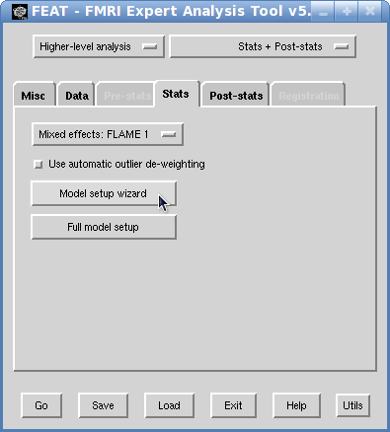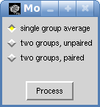

Post-stats Tab
As in our second level analysis, we now need to select the Post-stats tab and choose a Thresholding criterion. As I've mentioned, there is no 'one size fits all' multiple comparisons correction. So we will need to specify different methods depending on whether you're analyzing the face or motor task.
For the Face / Scene task Voxels along the fusiform gyrus are known to be highly sensitive to faces. However, the activation can be fairly localized (i.e., not many voxels in the cluster). This can make cluster correction too conservative. So to ensure that we see fusiform gyrus activation in our sample, we will use an Uncorrected threshold of .0005. So we're telling FSL to only show us voxels with very high z scores, but don't worry about whether there are a lot of them clustered together.
For the Motor task Basic motor and perception tasks create huge (by fMRI standards) activations. So we're going to use an extremely stringent statistical threshold. We will use a Cluster correction with a Z threshold of 4.27 (that's equal to p = .00001!!) and a Cluster P threshold of .01.
The uncorrected z-statistics image is always provided in addition to whatever thresholding criterion you choose.
1. Run your third level analysis
- Press the Go button.
A browser window should open and you can follow your results in the same way that you followed your second level results.
- Rerun the analysis for each of the four copes.
- Don't forget to change input and output directories for each cope.

Exploring your Third Level Analysis
Your analyses should be complete and it is now time to examine your results. As discussed above for the second level analysis, the HTML output is too inflexible to explore your results. I suggest you use FSLeyes.
As with the second level analysis, the statistical overlays are named thresh_zstat1.nii.gz and are located in a subdirectory (see warning box below) of each of the four output folders that you specified for your four third level analyses. One per COPE.
- allsubs_cope1.gfeat
- allsubs_cope2.gfeat
- allsubs_cope3.gfeat
- allsubs_cope4.gfeat
This gets confusing!
Each of your allsubs_copeX.gfeat directories has a cope1.feat subdirectory. This is where you will find the relevant results file, thresh_zstat1.nii.gz.
The confusing part is that the subdirectory is named cope1.gfeat regardless of the cope number of the parent directory! This is because third-level analysis focused on a single cope (e.g., cope 4), so the output directory will always be cope 1.
So, if you want to load your results for cope 4, you will find the file in allsubs_cope4.gfeat/cope1.feat.
The structure of FEAT results directories are like nested Russian dolls. Angry, bitter, unforgiving, Russian dolls. Be careful. Always be absolutely certain you are in the correct directory!!
Examine these results as you did before for the second level.
Remember from before,
- COPE1 is the main effect of Task B (face or right-hand)
- COPE2 is the main effect of Task A (scene or left-hand)
- COPE3 is the Task B vs Task A contrast and will only show voxels where Task B activated the voxel significantly more than Task A
- COPE4 is the Task A vs Task B contrast and will only show voxels where Task A activated the voxel significantly more than Task B
1. Display your group results
- Load the results from all four COPES overlaid on the MNI152_2mm_brain
  - Load the results from COPE1 and change the colorscale to Pink
  - Load the results from COPE2 and change the colorscale to Coppper
  - Load the results from COPE3 and change the colorscale to Red-Yellow
  - Load the results from COPE4 and change the colorscale to Blue-lightblue
Lab Report Part 2
- Include a figure that only displays the results of COPE1 and COPE2.
  - Are there regions that are commonly activated by both?
  - If yes, why?
- Include a figure that only displays the results of COPE3 and COPE4
  - For each of the two contrasts, identify two regions that seem to be selectively activated by one condition or another.
As with the second level analyses, FSL also stores the unthresholded (i.e., “raw”) z statistic volume in a subdirectory within your individual output folders called /stat. The relevant file here is zstat1.nii.gz. If you overlay this file, you will see what the z statistic was at every voxel in the brain. If you are still feeling adventurous, you can load this unthresholded z statistic image and use the contrast limits in FSLeyes to show only those voxels that are above a z score that you choose. For example, as discussed in a prior lab, you can choose a z score that is equivalent to a Bonferroni correction.

