THIS PAGE IS UNDER CONSTRUCTION

Electrodermal Activity

Useful links
- From a Biopac Webinar Series on EDA
  - Biopac EDA FAQ
  - Webinar I: How to acquire EDA data
  - Webinar I slides
  - Webinar I Q&A
  - Webinar II: How to analyze EDA data
  - Webinar II slides
- Introduction to electrodermal activity
- A Guide for Analysing Electrodermal Activity (EDA) & Skin Conductance Responses (SCRs) for Psychological Experiments
- Electrodermal activity measurements
- Biopac Electrodermal Response Basics
- EDA (GSR) subject preparation
- Guidelines for GSR, EDA, EDR, SCL, and SCR
Much of this information was gleaned from the following sources:
- Critchley, H.D. (2002). Electrodermal Responses: What Happens in the Brain. The Neuroscientist, 8(2), 132-142
- Boucsein, W., Fowles, D.C., Grimnes, S., Ben-Shakhar, G., Roth, W.T., Dawson, M.E., & Filion, D.L. (2012). Publication recommendations for electrodermal measurements. Psychophysiology, 49, 1017-1034.
- Braithwaite, J.J., Watson, D.G., Jones, R., Rowe, M. (2013). A Guide for Analysing Electrodermal Activity (EDA) and Skin Conductance Responses (SCRs) from Psychological Experiments.
There are several aspects of the EDA that one can measure:
- SC = Skin conductance. Measured in microsiemens or micromhos (the reciprocal of resistance, ohm)
- SCL = tonic changes in SC
  - note: we will generally not focus on SCL for a number of reasons. These include the fact that SCL will drift over time due to both physiological (SCRs can raise SCL) and non-physiological (polarization of electrodes in DC recording) factors.
- SCR = phasic changes in SC
- NS-SCR = SCRs that occur without any identifiable eliciting stimulus
- ER-SCR = SCR that is evoked by a specific eliciting stimulus
The onset of an ER-SCR will occur 1 to 3 seconds after the event and will have a rise-time (i.e. from initial deflection to peak amplitude) of 0.5 to 5 seconds.
10% of participants will be non-responders. That is, these individuals will not show an appreciable SCR.
Moreover, there are several ways to evaluate these responses. With regard to SCRs, one can
- evaluate the peak amplitude of the SCR
- evaluate the rise-time of the SCR
- evaluate the recovery time of the SCR
  - note: generally this is measured to 67% or 50% recovery because after an SCR there will likely be an increase in SCL. That is, the response will not completely recover to pre-SCR baseline.
- evaluate the frequency of NS-SCRs within a given epoch
- evaluate the rate of SCR habituation

Recording Electrodermal Responses

Initial Setup
- Power on the MP150
- Ensure that the EDA100C (Electrodermal Activity) amplifier is attached and set to channel #3
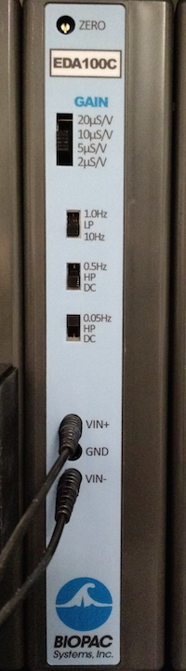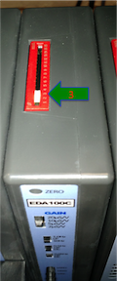

Electrode Setup
- Connect two LEAD110A leads into the EDA100C
  - Plug one lead into the Vin+ port and the other into the Vin- port
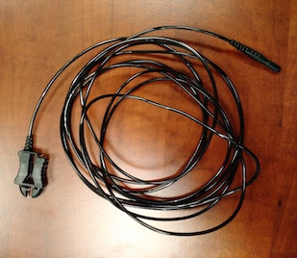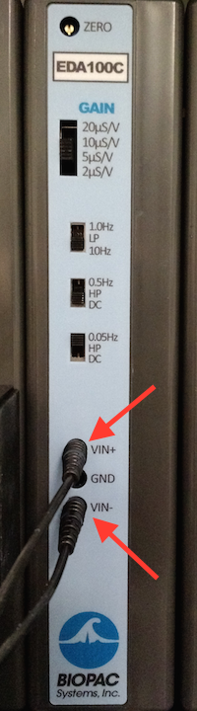
- Use electrode prep swab to clean the index and middle fingers of the participant's non-dominant hand (or not!?)
- Remove two EL507 electrodes.
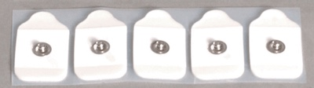el507
  - Put extra GEL101 on them
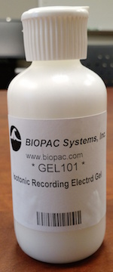gel101
  - You must use the specific SCR GEL101. Other conductive gels (e.g. the EEG gel) are not appropriate.
- Place them on the middle phalanx of the participant's index and middle fingers. Refer to the image below
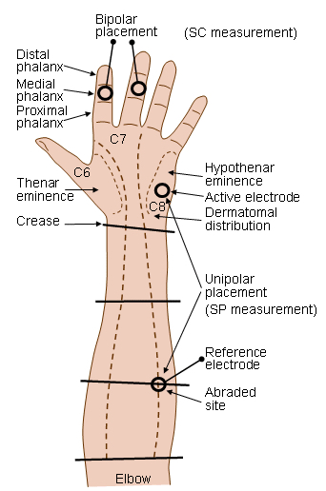http://www.bem.fi/book/27/27.htm
- Attach the pinch connector of one LEAD110A to the EL507 electrode on the middle finger, and the other to the EL507 electrode on the pointer finger.
- Wait at least five minutes before recording. The electrolyte gel will continue to penetrate into the stratum corneum, which will cause a drift in the ECL (specifically, increased conductivity).

